**SSN College of Engineering**

**Department of Computer Science and Engineering**

**UCS1512 – Microprocessors Lab**

**EX:09 – Floating Point Operations**

Exp No: 09 Name : Kshitij Sharma

Date: 15/10/2020 Reg No: 185001080

# Aim

To write programs for performing floating point operations in an 8086 microprocessor using MASM and DOSBox.

# Algorithm

1. Define the values in the data segment and assign the initial values if required
2. Initialize the data segment register with a data segment address
3. Initialize the 8087 stack
4. Load the data into the 8087 stack
5. Perform addition/ subtraction and store the sum/ difference to the result address in 8086 for display
6. Terminate the program

# Program for adding two floating point numbers

|  |  |
| --- | --- |
| **rogram** | **Comments** |
| CODESEG SEGMENT  start:  MOV AX,DATASEG MOV DS,AX | Initializing the data segment register with the data segment address |
| FINIT | Initialize the 8087 stack |
| FLD X FLD Y | Load X into ST(0)  Load Y into ST(0), X is now in ST(1) |
| FADD ST(0),ST(1) | Performing addition:  ST(0) = Y[ST(0)] + X[ST(1)] |
| FST SUM | Store ST(0) in sum |
| MOV AH,4CH INT 21H CODESEG ENDS  END START | Calling the DOS Function to enter the display screen using interrupt 21H and to terminate the program |

**Snapshot:**

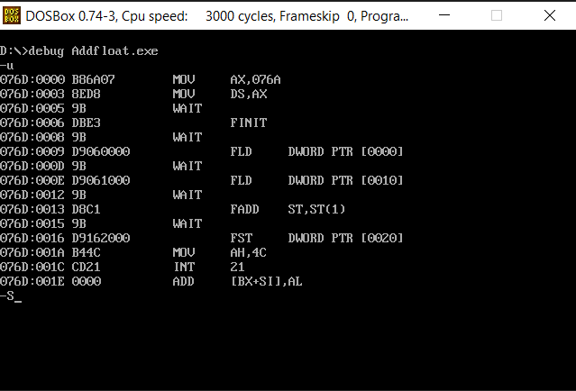

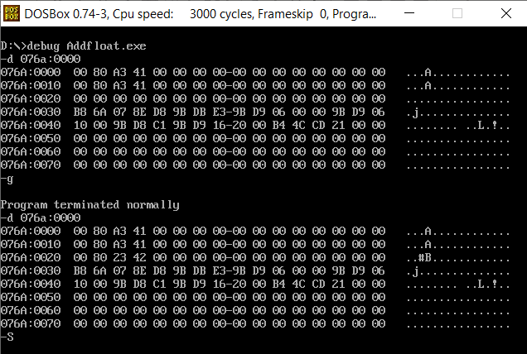

**Program for subtracting two floating point numbers**

|  |  |
| --- | --- |
| **Program** | **Comments** |
| CODESEG SEGMENT  start:  MOV AX,DATASEG MOV DS,AX | Initializing the data segment register with the data segment address |
| FINIT | Initialize the 8087 stack |
| FLD Y FLD X | Load Y into ST(0)  Load X into ST(0), Y is now in ST(1) |
| FSUB ST(0),ST(1) | Performing subtraction: ST(0) = X[ST(0)] - Y[ST(1)] |
| FST DIFF | Store ST(0) in diff |
| MOV AH,4CH INT 21H CODESEG ENDS  END START | Calling the DOS Function to enter the display screen using interrupt 21H and to terminate the program |

**Snapshot:**

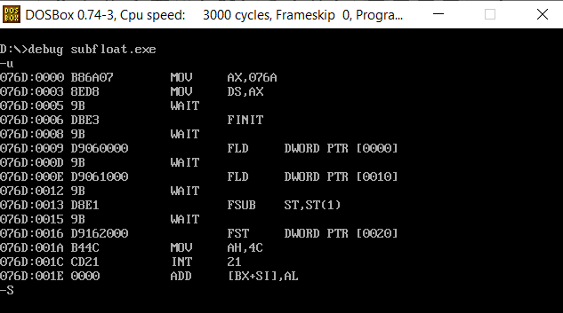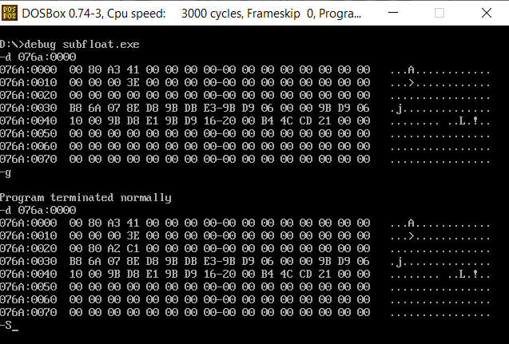

**Result**

Programs for performing floating point operations in an 8086 microprocessor using MASM and DOSBox were implemented and the outputs were verified.